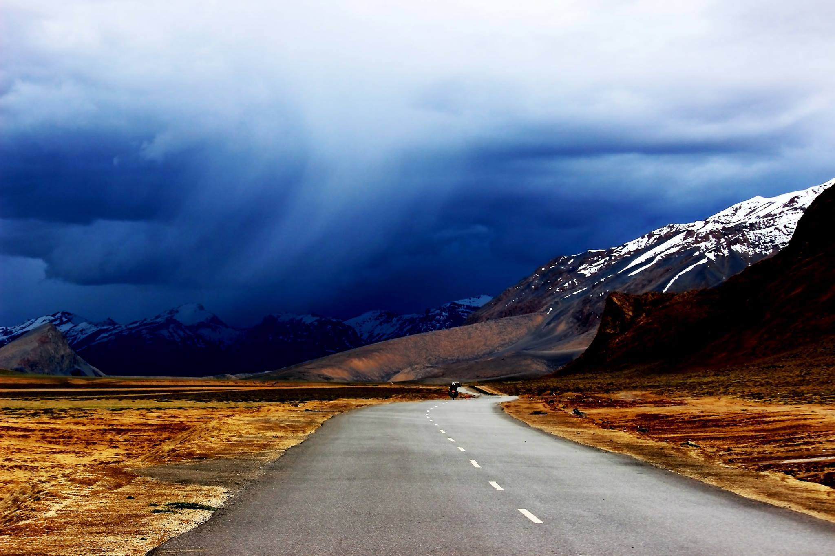

LADAKH TOUR PACKAGE - VIA SHYOK - PANGONG - LEH ROUTE
(Customized for TRAVEL MANAGEMENT, PUNE)
Tour Route: Leh- Indus Valley -- Sham Valley - Nubra Valley - Pangong Lake.
Duration: 06 nights / 07 days.
Day-1: Arrival Leh (Alt: 11500 / 3505 M)- Acclimatization / Visit City Centre..
Arrive Leh and transfer to the hotel. After welcome drink / breakfast take complete rest for acclimatization to the high altitude and rarefied air of Ladakh. In the late afternoon proceed on a short orientation tour of the old city centre and take leisurely walks through the main markets of this historic town.. Overnight at Leh.
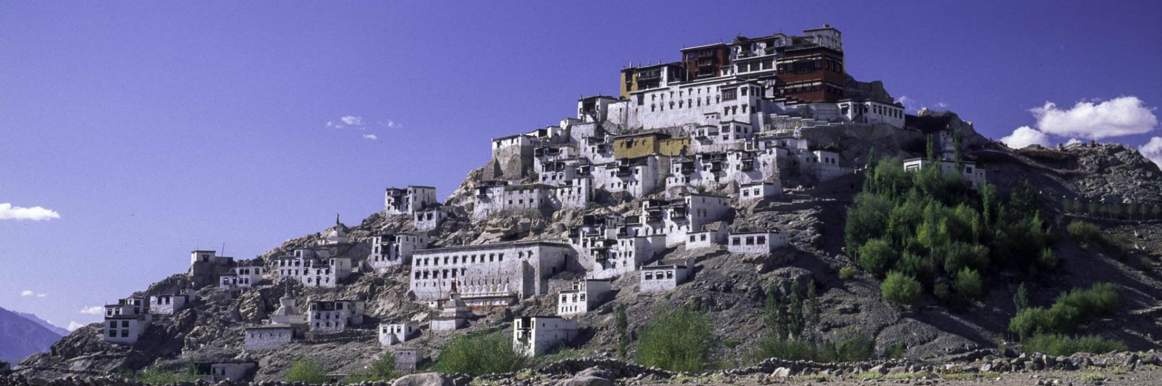
Day-2: In Leh: Visit Palaces & Monasteries.
After breakfast, proceed on sightseeing tour of the Indus Valley monasteries & palaces starting from the dramatically located Thiksey Monastery, a major Gelukpa foundation dating from the 16th century. Thereafter drive further up the Indus Valley to visit the 17th century Hemis Monastery, biggest monastery and principal seat of the Drukpa-Kargyut monastic order in the Ladakh region. A museum here displays the centuries-old art treasure of the monastery and is well worth exploring.
On the way back from Hemis, you may walk up the hill at Shey to visit Shey Palace, earliest royal capital of Ladakh founded in the 16th century. Within the complex you can view the two gigantic copper-gilt statues of the Buddha dating from the 17th century. Thereafter you may like to visit the Druk Padma School (of 3 Idiot Film fame) at Shey if interested . Overnight at Leh.
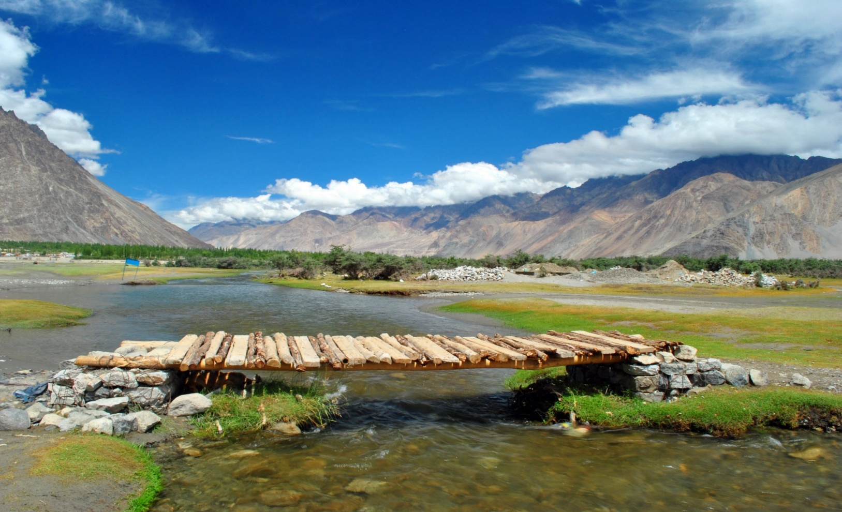

Day-3: Leh- Khardongla - Nubra Valley / 125 kms / 4-5 hours
After breakfast leave for Nubra Valley, driving across Khardong-la (alt: 18,380 ft.), highest motorable pass in the world. Nubra Valley lies between the Karakoram & Ladakh ranges at an average altitude of 10,000 ft. Till closure of the trans-Karakoram trade route by the Chinese in 1949, Nubra Valley was a busy route for the Central Asian trade
Reach Deskit (headquarters of Nubra valley) in the afternoon and visit the gigantic image of Maitreya Buddha (32 mtrs) seated out on a hillock which was inaugurated by The Dalai Lama in 2010, Thereafter drive on to Hunder & check-in at your accommodation. Later, proceed to explore the white Sand Dunes where you can also take a short camel Safari on the double-humped Bactrian camel found here (optional - direct payment). Overnight at Nubra. Day-4: Nubra Valley - Pangong Lake via Shyok -Durbuk Route / 155 kms. / 4 - 5 hours
Afternoon: Pangong to Leh via Changla pass / 150 kms. / 4- 5 hours..
After early breakfast, drive towards Pangong Lake along the Shyok River valley amidst spectacular mountain sceneries, en-route passing through the pretty villages of Aghyam, Shyok, Durbuk & Tangtse. Pangong Lake (alt: 14,500 ft.), the largest brackish water lake of Asia, is about 4-5 kms wide and about 135 kms long, of which some two-third portion lies on the other side of the Indo-China border.
After exploring the beauty of Pangong Lake for a couple of hours, drive back toward Leh via Chang-la pass (alt: 17370 ft/ 5486 meters), 3rd highest motorable pass in the world. Reach Leh in the evening. Overnight at Leh.

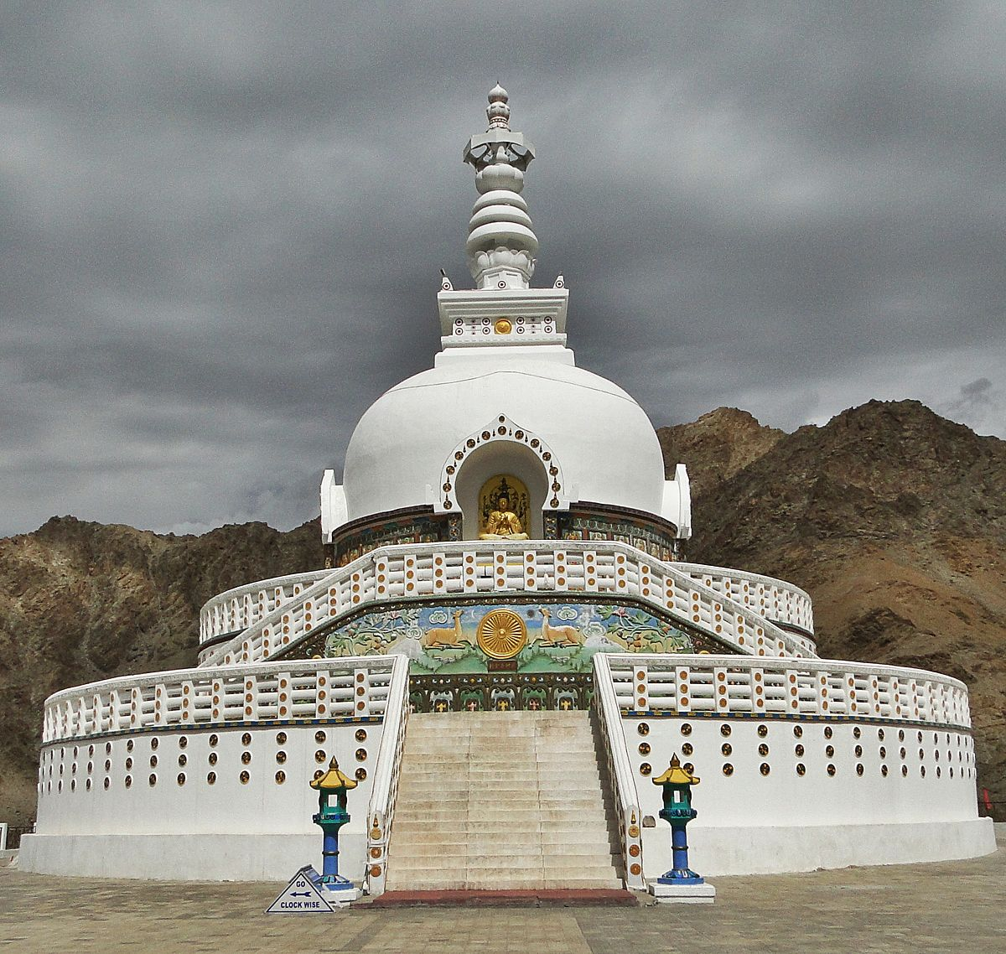
Day-5: In Leh: visit Shanti Stupa - Leh Palace – Leh City Centre / 3 - 4 hours
After leisurely breakfast or by lunch time, proceed on half day tour around Leh, visiting Shanti Stupa, a prominent landmark located on a great vantage point overlooking the valley, followed by visiting the 9-storied Leh Palace dating from the 1600 AD, a historic landmark of Leh which renders a unique heritage character to the town. Wind up the tour with a short walking tour of the main markets and exploring the city centre.
Overnight at Leh.

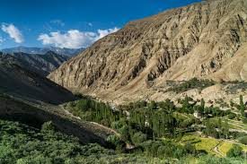
Day- 6: In Leh: Visit Alchi –Likir (Sham Valley) Circuit /180 kms round trip / 4-5 hours
After breakfast proceed to explore the Sham Valley circuit, driving all the way to Alchi and visit the 11th century Alchi Choskor, oldest surviving monastic complex of Ladakh and famous for its ancient wall frescoes and architecture – now a UNESCO listed heritage site. While returning towards Leh, drive up the hill to visit the 14th century Likir Monastery, where you can also view a recently installed colossal image of the Maitreya Buddha seated out in the open. Thereafter visit Sangam (confluence of Indus & Zanskar Rivers), Magnetic Point, Gurudwara Pathar Sahib and Hall of Fame (museum of military heritage).
Overnight at Leh.
Day-7: Departure Leh: Transfer to Airport.
Early morning transfer to the airport for taking the flight back home.
Remarks on the tour program:
i) Sequence of the day-wise tour program may change depending upon traffic schedules / restrictions on some roads and other unforeseen travel-related conditions TOUR COSTS: Cost Per Person in INR on MAP:
02 Pax in 01 room | 03 pax in 01 room | 04 Pax in  02 rooms | 06 pax in  02 rooms | 06 Pax in  3 rooms | 08 pax  04 rooms | 09 pax  03 rooms | 10 pax  05 rooms
39,000/- | 30,500/- | 28,500/- | 24,000/- | 25,000/- | 24,500/- | NA | 23,000/-
Taxes: GST Included.
PACKAGE INCLUSIONS:
- Accommodation on double / twin or triple sharing rooms (base category) in listed hotels..
- Daily breakfast & dinner – all in buffet on fixed menu) (06 b/fast & 06 dinners for each member)
- Transfers & Sightseeing by Non -A/C Taxi ( Xylo / Innova / Similar Vehicle for 02 to 0 6- pax group,
and by Tempo Traveler Coach for above 6 pax till 10 pax as per the itinerary
- Terms & conditions of the transport package / service. are as follows:-
  - The vehicle provided is for sightseeing on point–to-point basis as per the itinerary and not at disposal after the prescribed tour or outside the tour routes.
  - Places / sites not visited as per the given tour sequence / route on guest’s own advice / choice will not be revisited except on extra payment as per applicable transport rate.
  - Driver of the taxi is not a guide. He will only provide basic information about the tour routes.
  - Usage of the vehicle's AC will be on extra payment for the distance run with AC and this will be dealt with the driver of the vehicle directly.

- Innerline Permits, Ladakh Environment fee / wildlife fee / Red Cross fee.
- All expenses related to the driver & vehicle (except AC usage).
- No refund on unutilized services of the package (hotel, transport, meals etc.)

Hotels / camps to be used:
Leh : - Hotel Caravan Centre (05 nts):
Nubra:- Hotel Karma Inn / Himalayan Eco Resort / Similar at Hunder-Nubra (01 nts.).
Package Exclusions :
- Any expense of personal nature such as tips, laundry, telephone calls, fax etc.
- Entrance Fees for visiting Monument, Monasteries & Museums.
- Any kind of drinks (Alcoholic, Mineral, Aerated).
- Rafting / Camel Safari Charges, if any.
- Costs incidental to any change in the itinerary.
- Any expense incurred or loss caused by reasons beyond our control such as bad weather, natural calamities, flight delays / rescheduling / cancellations, any accidents / medical evacuations, riots/ strikes/war, & etc. - Anything not specifically mentioned under the head “Package Cost Inclusions”.
- Any expenses incurred on extra transport service
- Room service & additional meals.
- Medical & Travel insurance.
- Guide Fee, Camera Fee, if any.

General Terms & Conditions of Service & Payment:-
- 25% of the Tour Cost ( Non Refundable) for booking of the tour
- All bookings and confirmations are subject to availability in the specified hotels.
- Rates are subject to change without prior notice

